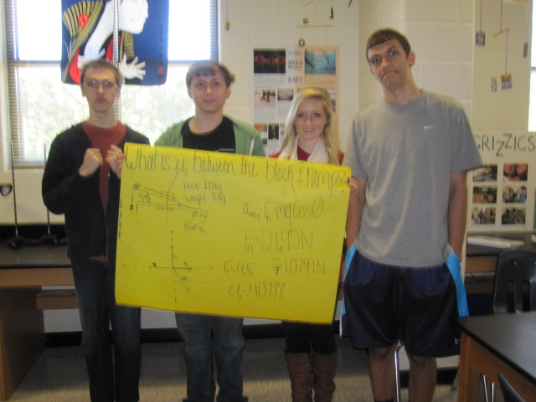
Stanton Caleb Claire and Lyums Force Lab

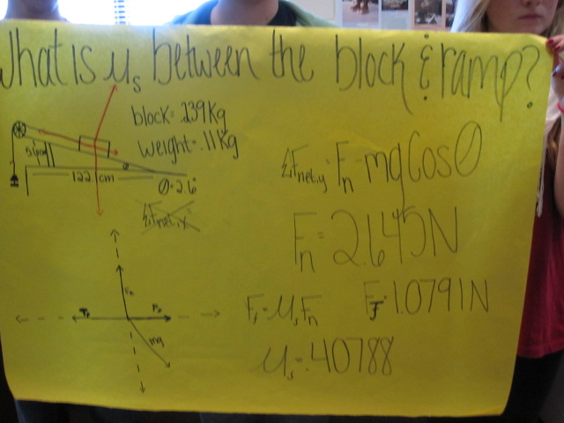
2) What is mu between the block and the weight?

