The Story
Herman the turtle has to cross a busy highway to meet a friend for lunch. He patiently waits for a break in the traffic before he begins to cross. He begins to move at constant and leisurely pace. After ten seconds have passed by, Herman has covered a distance of ten meters. At this time Herman notices an approaching vehicle and spins around to commence evasive action. After traveling two meters in three seconds it dons on him that he is moving too slow to escape an unfortunate demise, so he uses his shell-sliding ability to accelerate for two seconds until reaching a safe distance two meters away. After narrowly surviving the passing car Herman is exhausted and takes a five second break, but then resumes his trek. Frightened and alert Herman travels ten meters in ten more seconds. End in sight, he gradually slows down. It takes him ten seconds to cross the last five meters of the highway. Finally Herman has reached the other side and looks for his friend, only to realize that he crossed the wrong road.

The Graph I
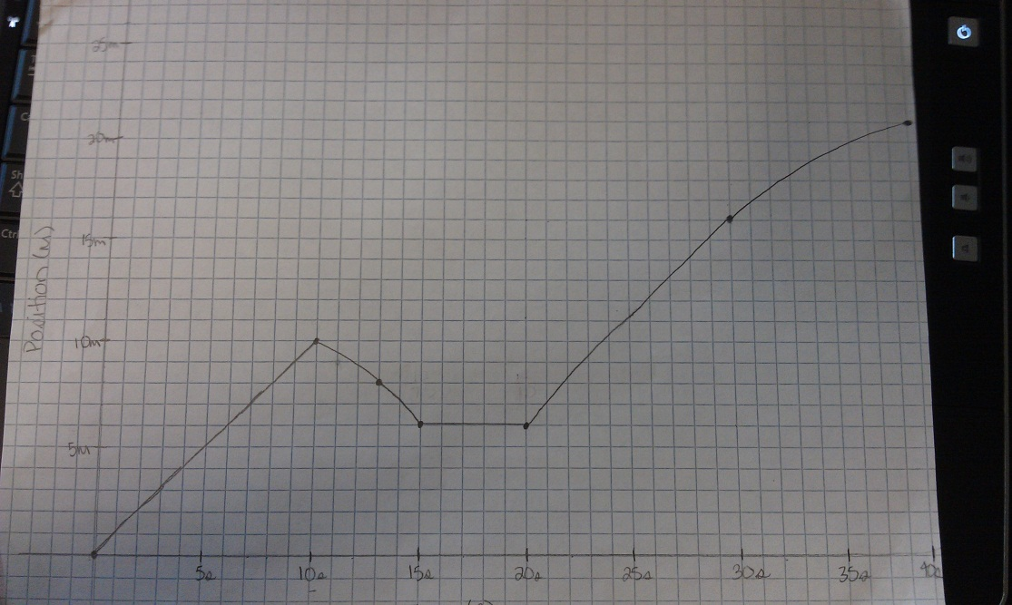

The Graph II
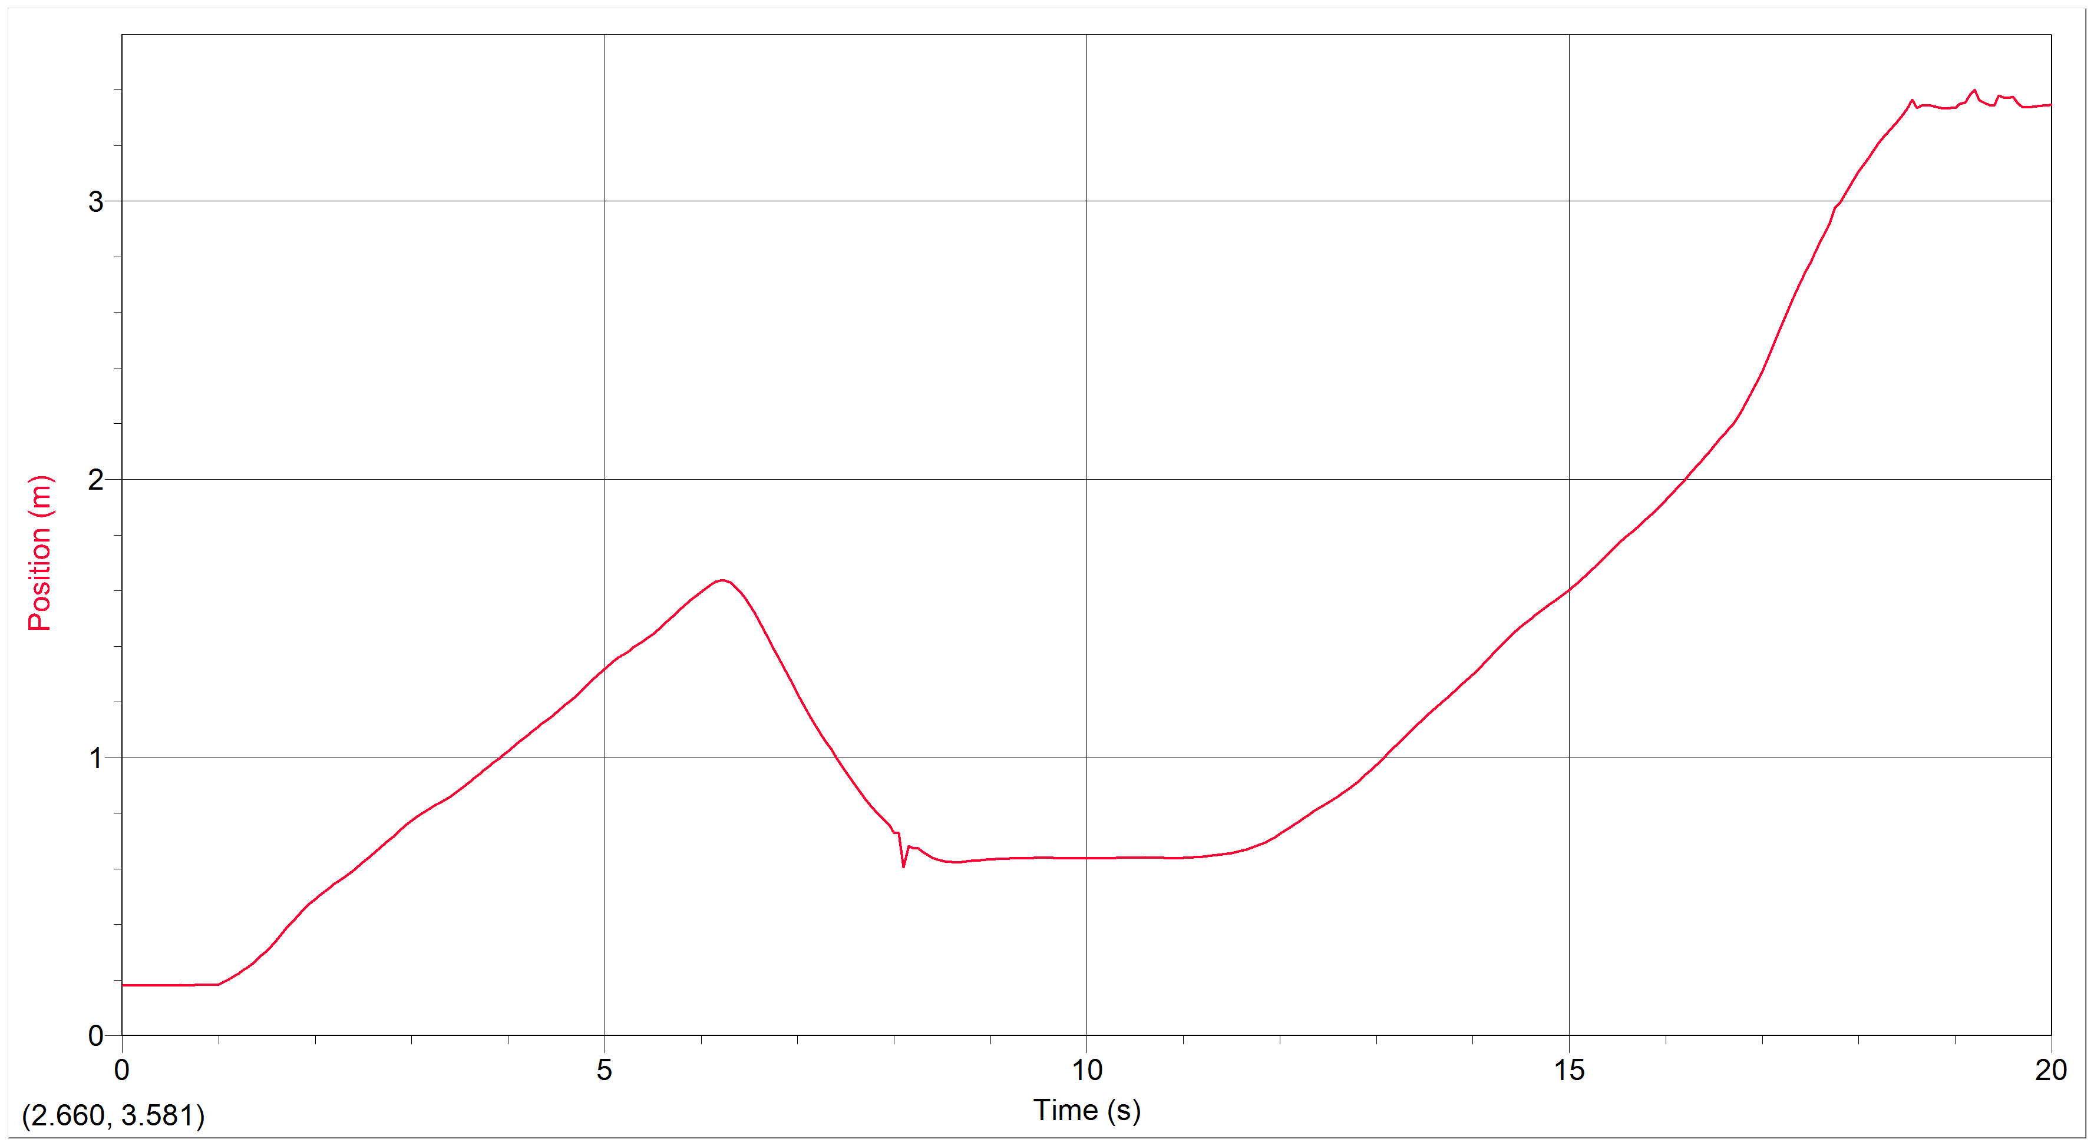
The Data Column
(time on the far left and positions in the other columns)

0 0.179 0.007 -0.071
0.05 0.179 0.004 -0.067
0.1 0.179 -0 -0.054
0.15 0.179 -0.002 -0.035
0.2 0.179 -0.004 -0.013
0.25 0.179 -0.004 0.03
0.3 0.179 -0.001 0.075
0.35 0.179 0.006 0.062
0.4 0.18 0.007 0.017
0.45 0.179 0.005 0.013
0.5 0.18 0.009 -0.001
0.55 0.18 0.009 -0.078
0.6 0.181 -0.004 -0.064
0.65 0.179 -0.005 0.071
0.7 0.18 0.01 0.085
0.75 0.181 0.011 -0.008
0.8 0.182 0.004 0.005
0.85 0.181 0.002 0.199
0.9 0.181 0.021 0.471
0.95 0.183 0.048 0.747
1 0.185 0.1 0.917
1.05 0.193 0.154 0.81
1.1 0.201 0.184 0.606
1.15 0.211 0.211 0.448
1.2 0.223 0.231 0.29
1.25 0.235 0.235 0.25
1.3 0.246 0.247 0.37
1.35 0.259 0.274 0.464
1.4 0.273 0.297 0.493
1.45 0.289 0.322 0.526
1.5 0.305 0.351 0.52
1.55 0.324 0.377 0.444
1.6 0.343 0.398 0.304
1.65 0.364 0.412 0.078
1.7 0.385 0.408 -0.176
1.75 0.405 0.389 -0.321
1.8 0.424 0.369 -0.34
1.85 0.442 0.355 -0.355
1.9 0.46 0.336 -0.404
1.95 0.476 0.312 -0.404
2 0.491 0.292 -0.33
2.05 0.505 0.279 -0.244
2.1 0.519 0.27 -0.194
2.15 0.532 0.26 -0.15
2.2 0.545 0.253 -0.079
2.25 0.557 0.252 0.003
2.3 0.57 0.254 0.075
2.35 0.582 0.259 0.146
2.4 0.595 0.268 0.215
2.45 0.609 0.283 0.233
2.5 0.624 0.296 0.166
2.55 0.639 0.301 0.06
2.6 0.654 0.3 -0.016
2.65 0.669 0.296 -0.027
2.7 0.683 0.295 0.017
2.75 0.698 0.298 0.062
2.8 0.713 0.303 0.056
2.85 0.729 0.308 -0.037
2.9 0.744 0.303 -0.188
2.95 0.759 0.288 -0.316
3 0.773 0.268 -0.371
3.05 0.786 0.247 -0.353
3.1 0.798 0.231 -0.3
3.15 0.809 0.218 -0.243
3.2 0.82 0.206 -0.164
3.25 0.83 0.199 -0.044
3.3 0.839 0.201 0.093
3.35 0.849 0.21 0.204
3.4 0.86 0.223 0.281
3.45 0.871 0.239 0.331
3.5 0.884 0.258 0.322
3.55 0.897 0.275 0.233
3.6 0.912 0.282 0.114
3.65 0.926 0.284 0.023
3.7 0.94 0.284 -0.047
3.75 0.954 0.279 -0.092
3.8 0.968 0.271 -0.064
3.85 0.981 0.27 0.012
3.9 0.995 0.275 0.053
3.95 1.009 0.278 0.058
4 1.023 0.28 0.059
4.05 1.037 0.283 0.055
4.1 1.051 0.287 0.023
4.15 1.066 0.287 -0.039
4.2 1.08 0.283 -0.093
4.25 1.094 0.275 -0.09
4.3 1.107 0.271 -0.036
4.35 1.121 0.272 0.012
4.4 1.135 0.273 0.045
4.45 1.148 0.276 0.075
4.5 1.162 0.282 0.078
4.55 1.177 0.285 0.071
4.6 1.191 0.287 0.123
4.65 1.205 0.295 0.216
4.7 1.22 0.31 0.263
4.75 1.236 0.327 0.198
4.8 1.253 0.334 0.06
4.85 1.27 0.329 -0.015
4.9 1.286 0.33 -0.057
4.95 1.303 0.329 -0.2
5 1.319 0.312 -0.377
5.05 1.334 0.287 -0.456
5.1 1.348 0.26 -0.399
5.15 1.36 0.242 -0.241
5.2 1.372 0.235 -0.069
5.25 1.383 0.241 -0.013
5.3 1.396 0.24 -0.052
5.35 1.407 0.229 0.027
5.4 1.418 0.236 0.21
5.45 1.43 0.254 0.332
5.5 1.444 0.273 0.379
5.55 1.458 0.294 0.36
5.6 1.473 0.314 0.251
5.65 1.49 0.32 0.131
5.7 1.505 0.324 0.041
5.75 1.522 0.326 -0.094
5.8 1.539 0.316 -0.24
5.85 1.554 0.299 -0.309
5.9 1.569 0.28 -0.27
5.95 1.582 0.268 -0.178
6 1.595 0.269 -0.244
6.05 1.609 0.259 -0.62
6.1 1.622 0.215 -1.182
6.15 1.632 0.138 -1.707
6.2 1.637 0.038 -2.074
6.25 1.636 -0.076 -2.257
6.3 1.63 -0.2 -2.187
6.35 1.615 -0.305 -1.915
6.4 1.598 -0.387 -1.676
6.45 1.577 -0.47 -1.462
6.5 1.551 -0.539 -1.163
6.55 1.522 -0.587 -0.854
6.6 1.491 -0.621 -0.599
6.65 1.459 -0.644 -0.398
6.7 1.427 -0.661 -0.212
6.75 1.393 -0.668 0.013
6.8 1.359 -0.656 0.152
6.85 1.327 -0.642 0.084
6.9 1.296 -0.645 -0.044
6.95 1.263 -0.654 -0.035
7 1.23 -0.656 0.141
7.05 1.197 -0.643 0.385
7.1 1.165 -0.613 0.538
7.15 1.135 -0.581 0.531
7.2 1.107 -0.556 0.414
7.25 1.08 -0.539 0.263
7.3 1.054 -0.529 0.115
7.35 1.028 -0.531 0.048
7.4 1 -0.531 0.112
7.45 0.974 -0.521 0.211
7.5 0.948 -0.505 0.229
7.55 0.924 -0.497 0.22
7.6 0.898 -0.488 0.298
7.65 0.875 -0.468 0.403
7.7 0.851 -0.448 0.507
7.75 0.829 -0.416 0.56
7.8 0.81 -0.384 0.404
7.85 0.791 -0.366 0.038
7.9 0.774 -0.359 -0.827
7.95 0.758 -0.45 -1.427
8 0.729 -0.501 -1.455
8.05 0.727 -0.803 1.991
8.1 0.605 -0.367 6.171
8.15 0.681 0.221 3.241
8.2 0.674 0.012 -0.975
8.25 0.673 -0.098 -1.637
8.3 0.661 -0.197 -1.003
8.35 0.65 -0.199 0.029
8.4 0.64 -0.173 0.604
8.45 0.632 -0.125 0.849
8.5 0.628 -0.075 0.788
8.55 0.625 -0.042 0.616
8.6 0.624 -0.018 0.488
8.65 0.623 0.006 0.38
8.7 0.625 0.023 0.24
8.75 0.626 0.03 0.1
8.8 0.628 0.031 0.002
8.85 0.629 0.029 -0.058
8.9 0.631 0.024 -0.081
8.95 0.632 0.018 -0.047
9 0.632 0.019 -0.01
9.05 0.634 0.02 -0.025
9.1 0.635 0.017 -0.05
9.15 0.635 0.013 -0.042
9.2 0.636 0.011 -0.005
9.25 0.636 0.013 0.016
9.3 0.637 0.015 -0.009
9.35 0.638 0.013 -0.048
9.4 0.638 0.009 -0.067
9.45 0.639 0.005 -0.066
9.5 0.639 0.003 -0.064
9.55 0.639 -0.002 -0.051
9.6 0.639 -0.002 -0.04
9.65 0.639 -0.005 -0.041
9.7 0.638 -0.008 -0.018
9.75 0.638 -0.007 0.022
9.8 0.637 -0.004 0.037
9.85 0.637 -0.003 0.032
9.9 0.637 -0.002 0.038
9.95 0.637 0.001 0.047
10 0.637 0.004 0.026
10.05 0.638 0.004 -0.005
10.1 0.638 0.002 -0
10.15 0.638 0.003 0.027
10.2 0.638 0.006 0.034
10.25 0.638 0.008 0.019
10.3 0.639 0.007 0.008
10.35 0.639 0.008 0.005
10.4 0.64 0.009 -0.013
10.45 0.64 0.007 -0.046
10.5 0.64 0.003 -0.063
10.55 0.64 0.001 -0.068
10.6 0.641 -0.004 -0.068
10.65 0.64 -0.008 -0.038
10.7 0.64 -0.008 0
10.75 0.639 -0.006 0.016
10.8 0.639 -0.006 0.033
10.85 0.638 -0.005 0.077
10.9 0.638 0.001 0.122
10.95 0.638 0.009 0.132
11 0.639 0.016 0.109
11.05 0.64 0.02 0.085
11.1 0.641 0.023 0.081
11.15 0.642 0.028 0.086
11.2 0.644 0.033 0.076
11.25 0.646 0.036 0.065
11.3 0.648 0.038 0.08
11.35 0.649 0.043 0.107
11.4 0.652 0.049 0.125
11.45 0.654 0.055 0.152
11.5 0.657 0.064 0.18
11.55 0.661 0.073 0.212
11.6 0.665 0.084 0.262
11.65 0.669 0.1 0.3
11.7 0.675 0.116 0.312
11.75 0.681 0.131 0.318
11.8 0.688 0.146 0.349
11.85 0.695 0.165 0.391
11.9 0.704 0.188 0.374
11.95 0.714 0.207 0.285
12 0.725 0.217 0.19
12.05 0.736 0.223 0.14
12.1 0.747 0.231 0.095
12.15 0.759 0.233 0.039
12.2 0.771 0.233 0.007
12.25 0.783 0.234 -0.025
12.3 0.794 0.232 -0.08
12.35 0.806 0.225 -0.116
12.4 0.817 0.217 -0.079
12.45 0.827 0.216 -0.003
12.5 0.838 0.218 0.059
12.55 0.849 0.222 0.119
12.6 0.86 0.229 0.181
12.65 0.872 0.24 0.227
12.7 0.884 0.253 0.263
12.75 0.897 0.267 0.295
12.8 0.911 0.282 0.311
12.85 0.925 0.3 0.281
12.9 0.941 0.313 0.205
12.95 0.957 0.319 0.155
13 0.973 0.325 0.17
13.05 0.989 0.337 0.171
13.1 1.007 0.347 0.088
13.15 1.024 0.347 -0.013
13.2 1.042 0.343 -0.061
13.25 1.058 0.337 -0.044
13.3 1.075 0.337 -0.002
13.35 1.092 0.339 0.008
13.4 1.109 0.34 -0.022
13.45 1.126 0.337 -0.075
13.5 1.143 0.334 -0.155
13.55 1.16 0.323 -0.245
13.6 1.175 0.302 -0.203
13.65 1.189 0.298 -0.062
13.7 1.205 0.301 0.01
13.75 1.22 0.3 0.05
13.8 1.235 0.303 0.121
13.85 1.25 0.316 0.136
13.9 1.267 0.32 0.094
13.95 1.282 0.32 0.141
14 1.298 0.331 0.235
14.05 1.315 0.348 0.243
14.1 1.333 0.36 0.154
14.15 1.351 0.365 0.016
14.2 1.37 0.361 -0.106
14.25 1.388 0.35 -0.145
14.3 1.405 0.343 -0.11
14.35 1.422 0.343 -0.132
14.4 1.439 0.335 -0.25
14.45 1.456 0.316 -0.338
14.5 1.471 0.295 -0.303
14.55 1.485 0.282 -0.197
14.6 1.499 0.278 -0.143
14.65 1.513 0.271 -0.145
14.7 1.526 0.262 -0.116
14.75 1.539 0.258 -0.059
14.8 1.552 0.258 -0.024
14.85 1.565 0.256 0.001
14.9 1.577 0.255 0.075
14.95 1.59 0.262 0.184
15 1.603 0.276 0.252
15.05 1.617 0.289 0.271
15.1 1.632 0.305 0.242
15.15 1.648 0.315 0.182
15.2 1.664 0.322 0.152
15.25 1.68 0.327 0.176
15.3 1.696 0.339 0.189
15.35 1.714 0.353 0.077
15.4 1.732 0.349 -0.089
15.45 1.749 0.34 -0.192
15.5 1.766 0.329 -0.251
15.55 1.782 0.312 -0.238
15.6 1.797 0.3 -0.123
15.65 1.812 0.3 0.003
15.7 1.827 0.304 0.068
15.75 1.842 0.307 0.115
15.8 1.858 0.314 0.174
15.85 1.873 0.325 0.216
15.9 1.89 0.338 0.216
15.95 1.907 0.348 0.19
16 1.925 0.355 0.194
16.05 1.943 0.366 0.222
16.1 1.961 0.378 0.23
16.15 1.98 0.393 0.154
16.2 2.001 0.398 -0.001
16.25 2.021 0.39 -0.088
16.3 2.04 0.381 -0.009
16.35 2.058 0.384 0.164
16.4 2.078 0.403 0.216
16.45 2.099 0.416 0.076
16.5 2.12 0.413 -0.09
16.55 2.141 0.397 -0.041
16.6 2.159 0.393 0.326
16.65 2.179 0.424 0.803
16.7 2.201 0.482 1.117
16.75 2.226 0.55 1.122
16.8 2.256 0.603 0.92
16.85 2.287 0.639 0.751
16.9 2.32 0.673 0.694
16.95 2.355 0.704 0.737
17 2.39 0.745 0.795
17.05 2.429 0.792 0.697
17.1 2.47 0.825 0.401
17.15 2.513 0.827 0.144
17.2 2.552 0.837 -0.085
17.25 2.597 0.828 -0.438
17.3 2.637 0.787 -0.652
17.35 2.676 0.747 -0.561
17.4 2.711 0.723 -0.307
17.45 2.747 0.72 -0.115
17.5 2.782 0.723 -0.114
17.55 2.82 0.712 -0.13
17.6 2.855 0.693 0.089
17.65 2.887 0.71 0.367
17.7 2.921 0.792 -0.416
17.75 2.977 0.689 -1.511
17.8 2.992 0.553 -1.097
17.85 3.023 0.566 -0.363
17.9 3.05 0.556 -0.224
17.95 3.079 0.551 -0.281
18 3.106 0.527 -0.374
18.05 3.132 0.505 -0.309
18.1 3.156 0.496 -0.259
18.15 3.181 0.487 -0.359
18.2 3.206 0.461 -0.47
18.25 3.227 0.436 -0.48
18.3 3.249 0.408 -0.356
18.35 3.268 0.386 0.008
18.4 3.286 0.413 0.115
18.45 3.308 0.442 -0.696
18.5 3.332 0.418 -2.669
18.55 3.366 0.112 -3.418
18.6 3.336 -0.074 -1.493
18.65 3.343 0.009 -0.2
18.7 3.344 -0.012 -0.292
18.75 3.343 -0.035 -0.308
18.8 3.34 -0.062 -0.036
18.85 3.335 -0.051 0.537
18.9 3.333 0.002 0.951
18.95 3.336 0.047 1.274
19 3.336 0.133 1.438
19.05 3.35 0.207 1.047
19.1 3.355 0.279 -0.265
19.15 3.381 0.266 -2.849
19.2 3.402 -0.086 -3.744
19.25 3.364 -0.301 -1.033
19.3 3.354 -0.182 1.752
19.35 3.347 -0.039 2.796
19.4 3.344 0.2 1.654
19.45 3.38 0.198 -0.933
19.5 3.373 0.012 -1.936
19.55 3.371 -0.035 -1.963
19.6 3.376 -0.187 -1.546
19.65 3.35 -0.269 0.259
19.7 3.337 -0.139 1.6
19.75 3.338 -0.024 1.396
19.8 3.34 0.016 0.734
19.85 3.341 0.028 0.362
19.9 3.343 0.033 0.393
19.95 3.343 0.062 0.573
20 3.349 0.101 0.701

